**JAVA Assignments(Day-4 Control Statements)**

1. **Consider the following code snippet:**

**if (number1>= 0) if (number1== 0)**

**System.out.println("first"),**

**else**

**System.out.println("second"); System.out.println("third"),**

**Exercise: What output do you think the code will produce if number is 3?**

The output will be:

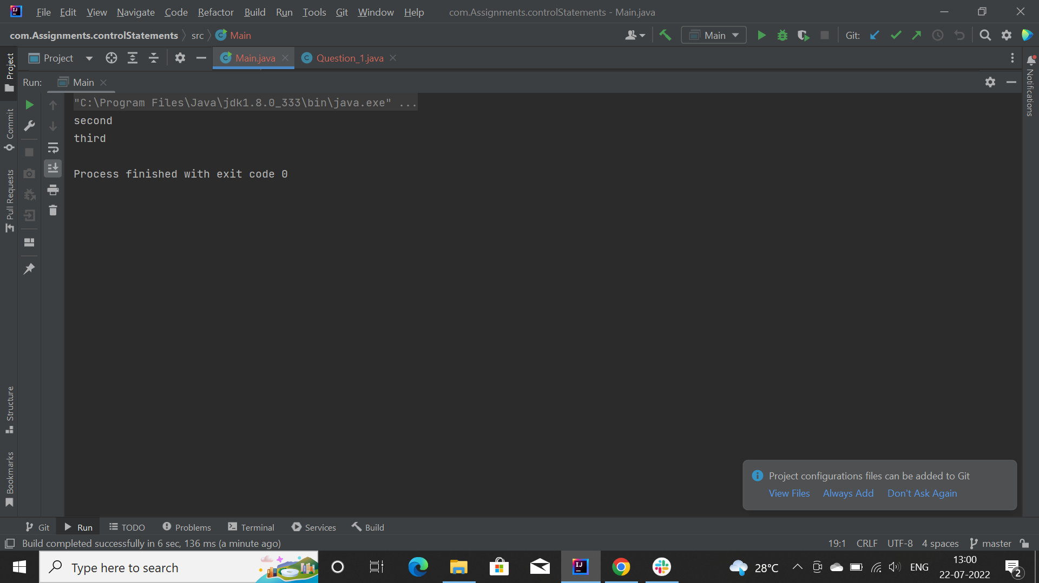

**2) Using only spaces and line breaks, reformat the above Q1 code snippet, to make the control flow easier to understand.**

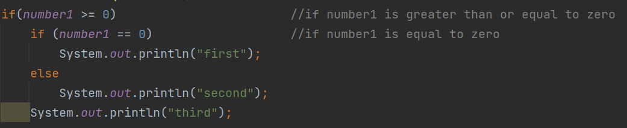

**3) Convert the following if-else-if code into switch case : for temperature**

**switch case for temperature**

**System.out.println("low"), else if(var == 2)**

**System.out.println("medium");**

**else if(var == 3)**

**System.out.println("high")) else**

**System.out.println("abnormal");**

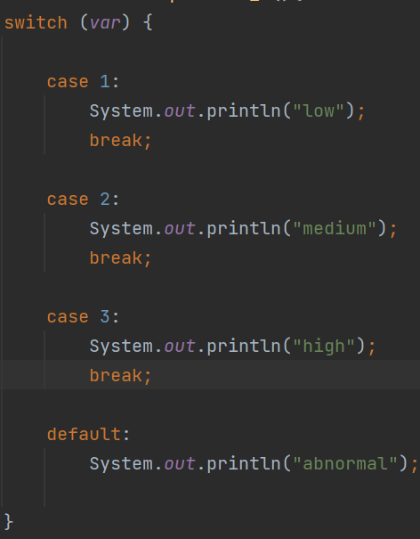

**4) Rewrite the following program code using the suitable ‘if’ command.**

**switch(m){ case 0:**

**x=x+2;**

**System.out.println("X=" x);**

**break;**

**case 1: Tx=x+4;**

**System.out.println("X=" x);**

**break; case 2:**

**x=x+6;**

**System.out.println("X=" x);**

**break; }**

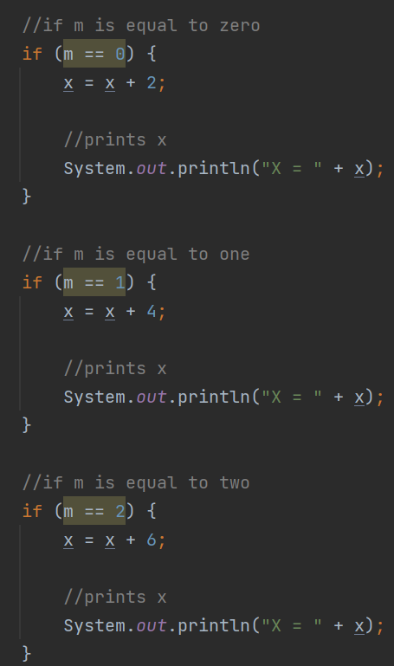

**5) Take two int values from the user and print greatest amongst them.**

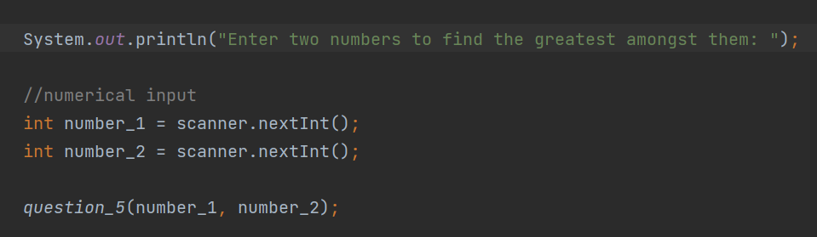

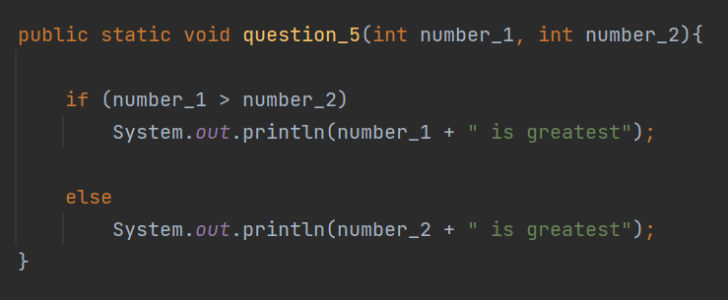

**6) Take input of age of 3 people by user and determine oldest and youngest among them. (by applying age criteria)**

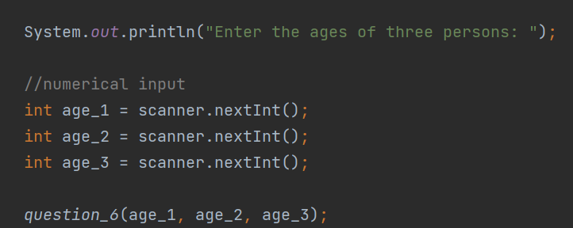

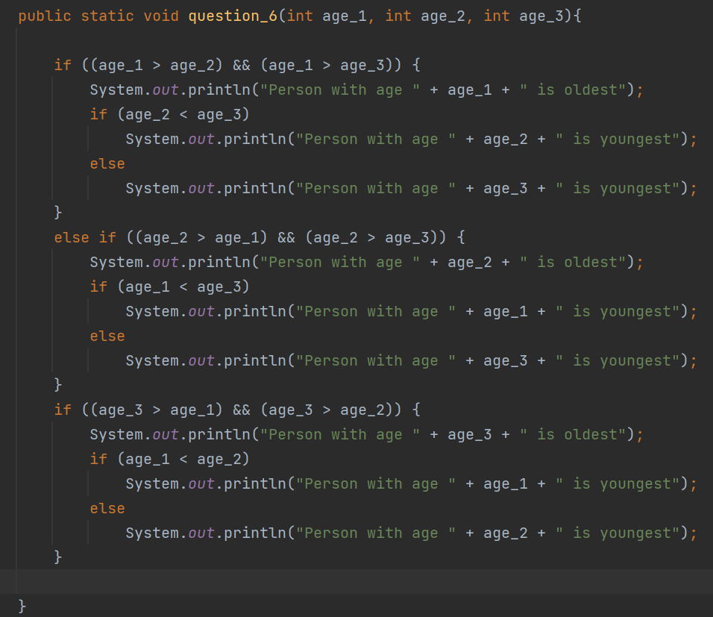

**7) Perform below operations:**

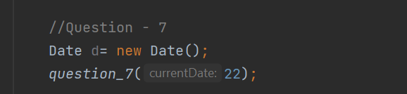

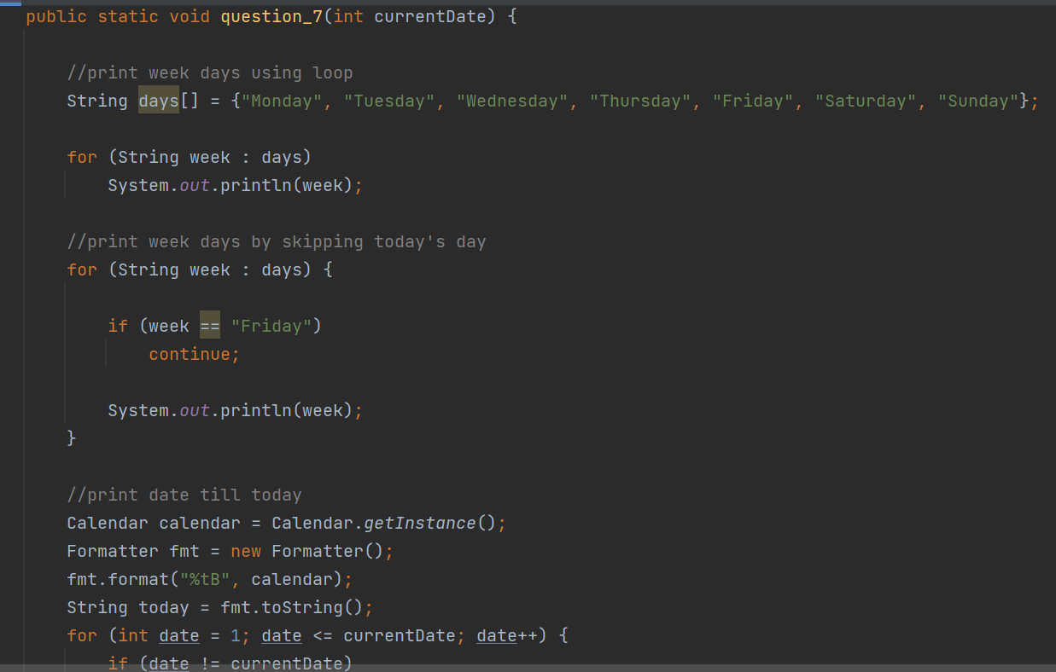

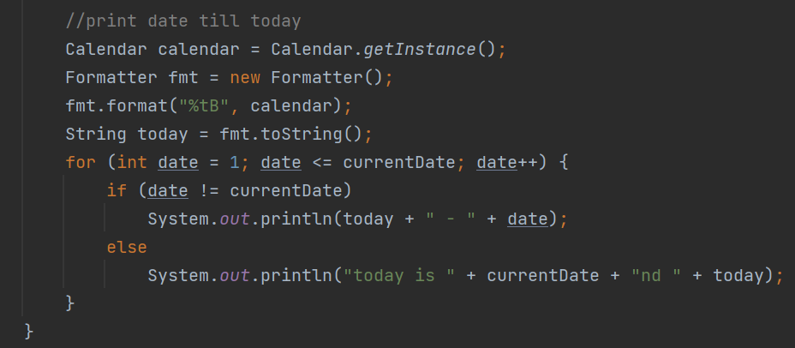

**8) Star Pattern:**

